DATA EXPLORATION:

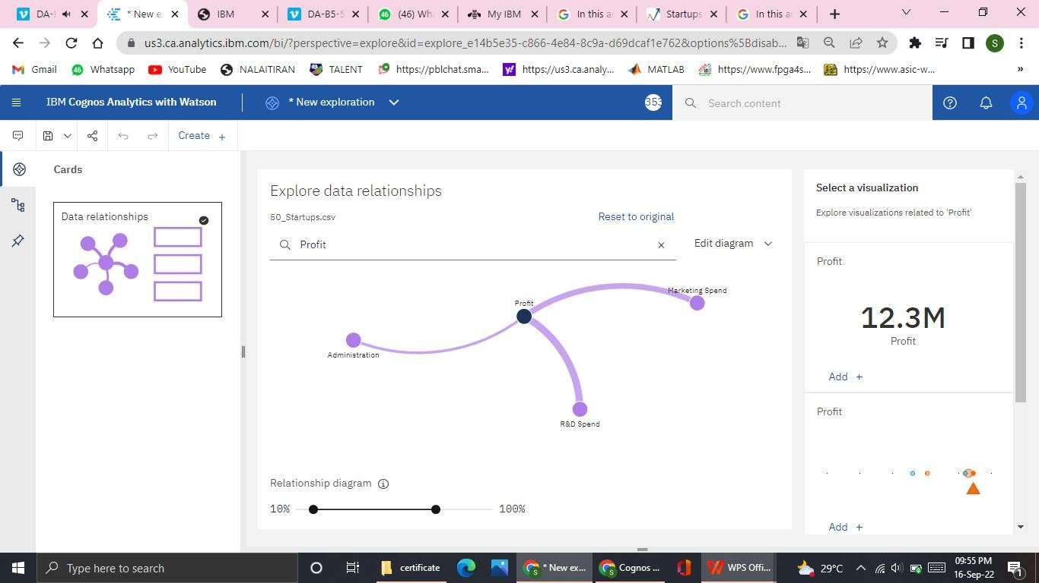

DATA VISUALIZATION

Profit by State colored by Profit(AVERAGE) - BAR GRAPH

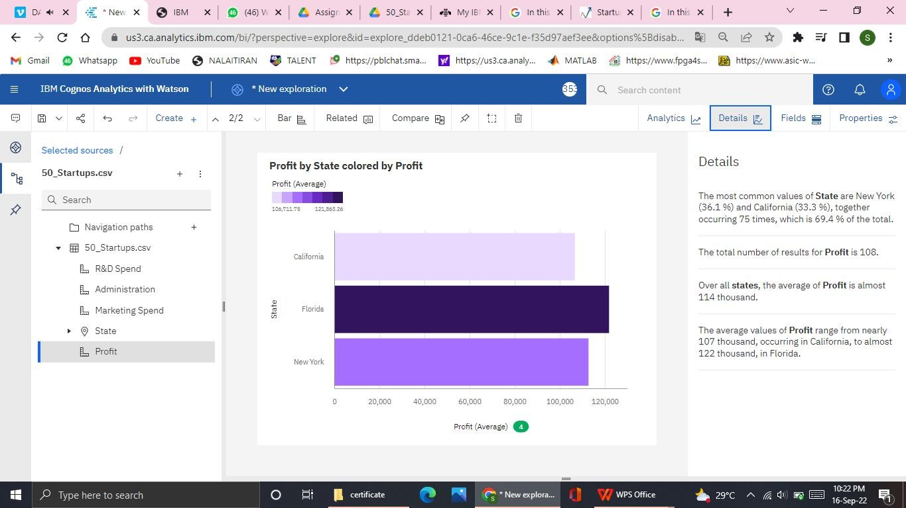

Florida has nearly 122000 profit average.

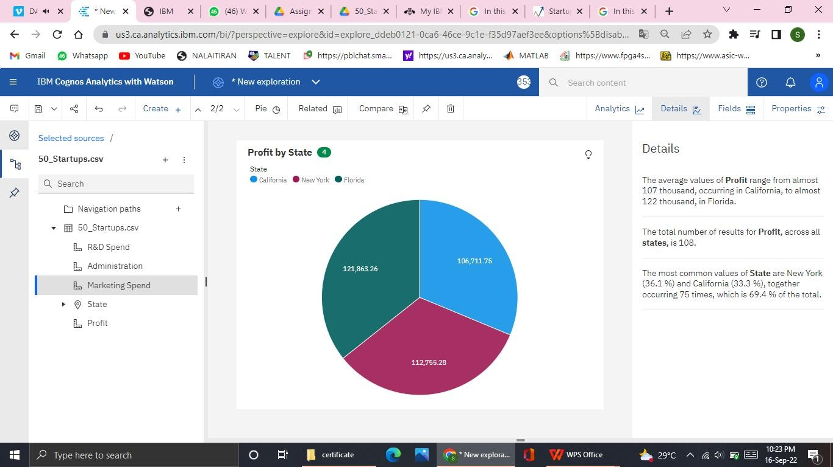

Newyork State has high profit rate when compared to all other states.

Profit for State and Marketing Spend (CROSS TABLE)

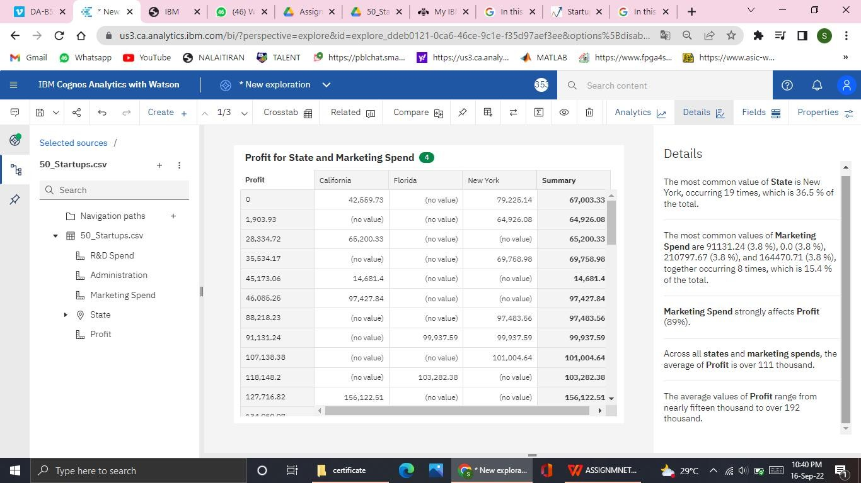

**Marketing Spend** strongly affects **Profit**

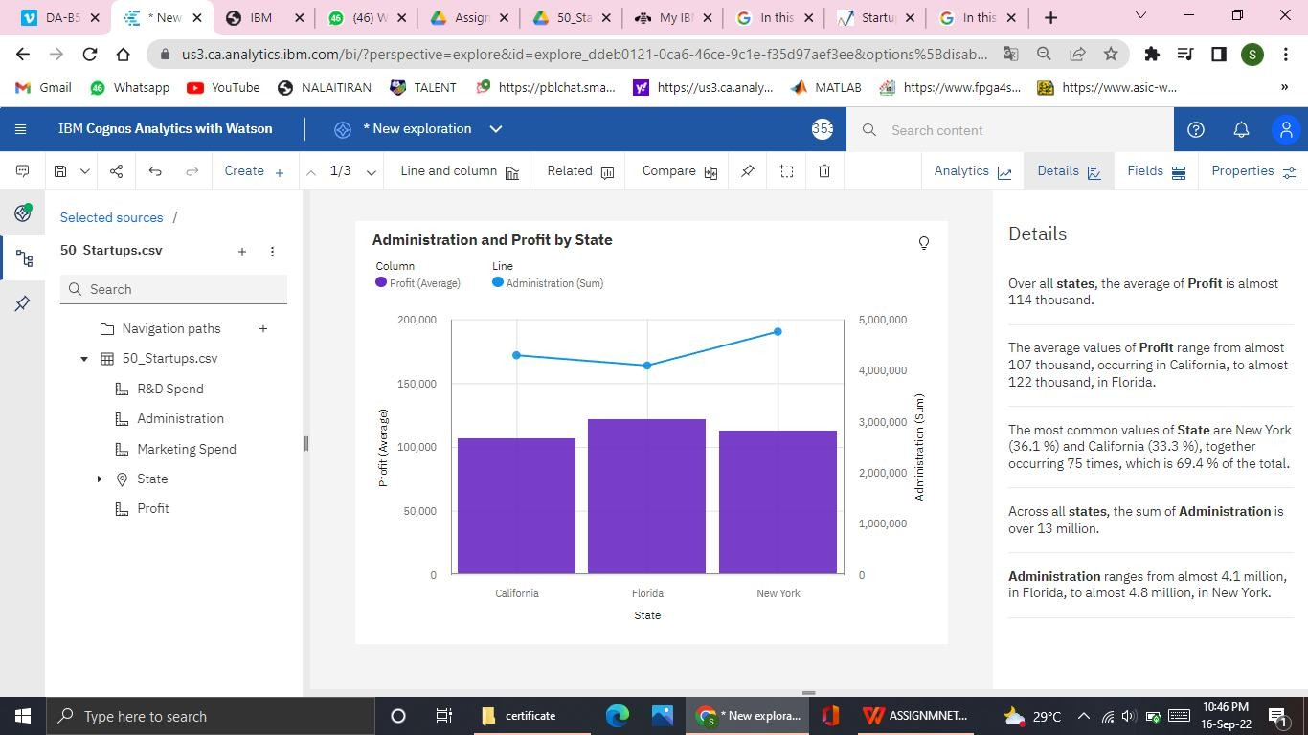

Profit by R&D Spend colored by Profit ( STACKED BAR)

